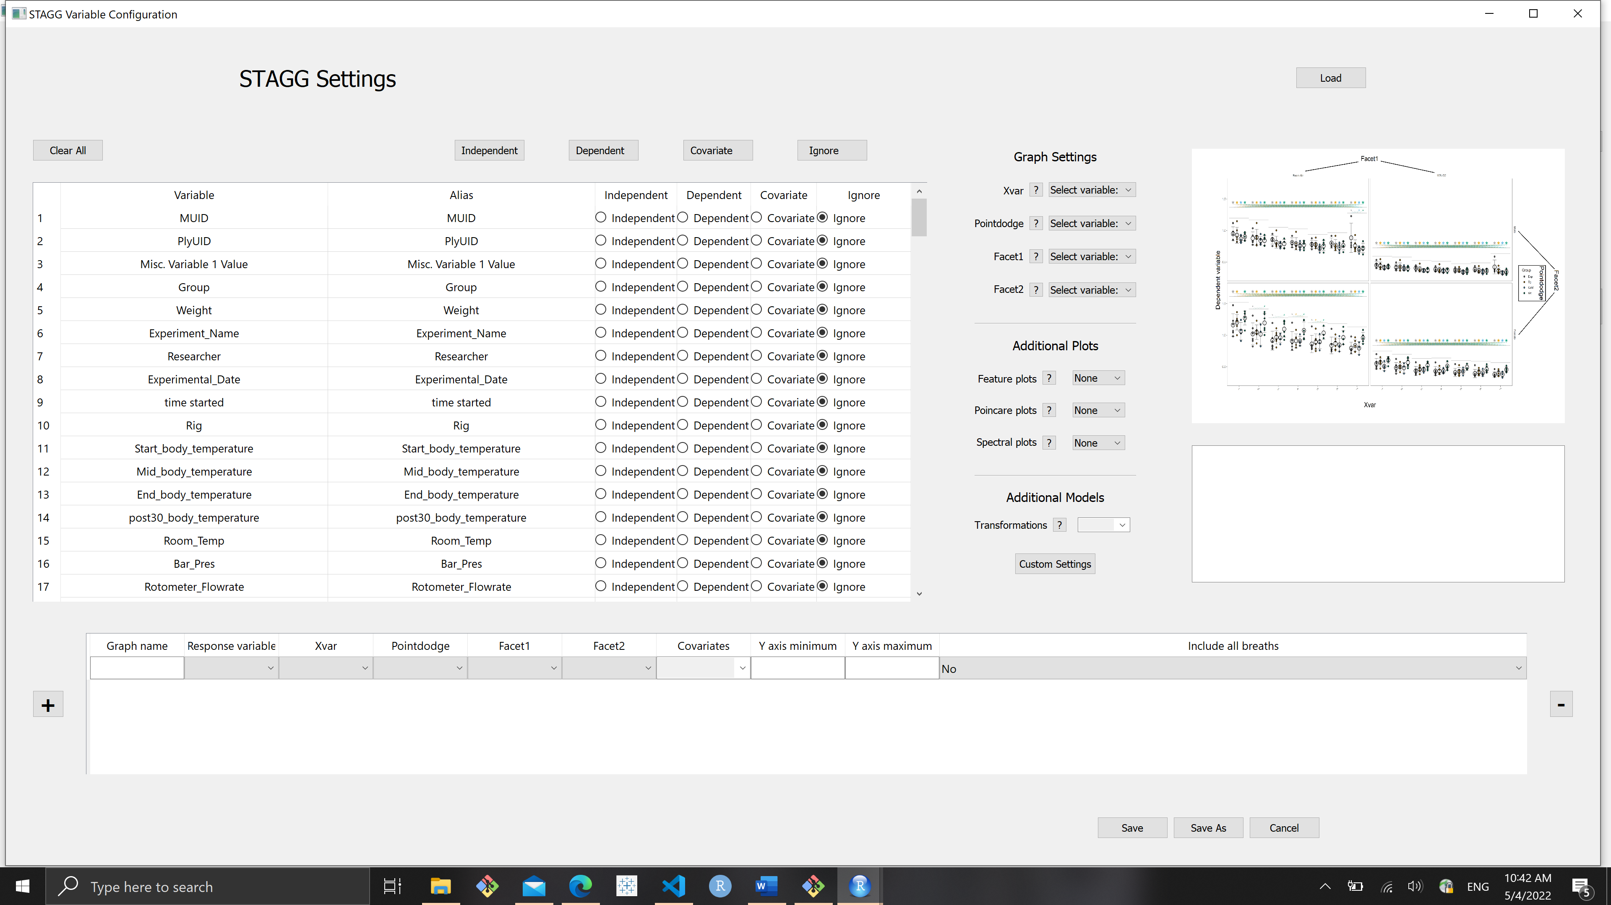

Config.loop_table situation, including all the stuff you already know:

1. Graph name
   1. Input not required.
      1. STAGG doesn’t need this value to make a graph.
   2. No dependencies.
      1. The user can interact with the widget whenever.
   3. Contents:
      1. It’s an embedded LineEdit. If the user wants to give the graph a particular name, then they can type it in there. If the user leaves it blank, then STAGG comes up with an automatic name.
      2. Are there rules as far as forbidden characters? – Avery will ask Andersen
2. Response variable
   1. Input required.
      1. The user will not get an optional graph without this value. STAGG may punish them. Validation would help protect users from themselves. I prefer the validation occur when they hit OK or Save As so that we don’t bitch at them before they’re actually done picking their settings.
   2. No dependencies.
      1. The user can interact with this widget whenever.
   3. Contents:
      1. ComboBox that should list Aliases of all variables. Pre-Shaun, it’s populated with [x for x in Plethysmography.breath_df].
   4. Behaviors:
      1. Only one value can be selected. (It’s a normal ComboBox.)
      2. If the user edits an Alias in Config.variable_table, the corresponding Alias listed in this ComboBox should be updated to reflect that.
         1. If the edited Alias is the .CurrentText(), then it should be updated and remain the .CurrentText().
3. Xvar
   1. Input required.
      1. No xvar, no graph.
   2. Dependencies?
      1. Eh. Forcing their hand by making them choose a response variable before they can interact with this widget could help protect users from themselves.
   3. Contents:
      1. ComboBox that should list Aliases of all variables (x for x in Plethsymography.breath_df) EXCEPT the value selected for Response variable.
   4. Behaviors:
      1. Only one value can be selected. (It’s a normal ComboBox.)
      2. If the user edits an Alias in Config.variable_table, the corresponding Alias listed in this ComboBox should be updated to reflect that.
         1. If the edited Alias is the .CurrentText(), then it should be updated and remain the .CurrentText().
      3. This value has to be a categorical variable. I believe STAGG will still make the graph if the user chooses a continuous variable, but the stats would be bunk and the graph would be ridiculous. Or R wouldn’t have enough memory to do that many comparisons.
         1. Validation would require some gymnastics and would definitely qualify as an enhancement as opposed to a necessity. Users can read.
            1. It would require checking the contents of this variable, which would mean accessing something other than breath_df (which is just a list of the variables.)
            2. ~~If Config.variable_table is populated by scraping the appropriate keys from a JSON (produced as BASSPRO output and selected by the user as STAGG input – which JSON? My uninspired method would be to find the first item in stagg_list (pre-Shaun Plethysmography attribute) that ends in “.json”, which is not foolproof but would work in the majority of situations. Grab the data type of the first non-NA value for the key that corresponds to the Alias selected in the ComboBox?~~
            3. ~~If Config.variable_table is populated via metadata, BASSPRO settings, and variables scraped from a chunk of html embedded in python_module.py, then we’d be able to check the contents of variables from metadata and settings but we would have no values for the scraped variables.~~

~~Given that the settings variables and scraped variables will be the same data type regardless of the user or the run – Auto_Condition will always be categorical, VEVO2, will always be continuous – we could have a dictionary~~

~~This is gross and I’m moving on. They can read the documentation.~~

1. Pointdodge
   1. Input not required.
   2. Dependencies:
      1. The user can’t interact with this widget unless they’ve selected an Xvar value.
   3. Contents:
      1. ComboBox that should list Aliases of all variables (x for x in Plethsymography.breath_df) EXCEPT the ones selected for Response variable and Xvar. If the user has selected any values for Covariates, then those values should also be excluded from the list of variables displayed.
         1. Feature creep – could the value be greyed out instead of just deleted?
   4. Behaviors:
      1. Only one value can be selected. (It’s a normal ComboBox.)
      2. If the user edits an Alias in Config.variable_table, the corresponding Alias listed in this ComboBox should be updated to reflect that.
         1. If the edited Alias is the .CurrentText(), then it should be updated and remain the .CurrentText().
      3. This value has to be a categorical variable. Otherwise the graph is absurd.
2. Facet1
   1. Input not required.
   2. Dependencies:
      1. The user can’t interact with this widget unless they’ve selected an Pointdodge value (and therefore an Xvar value).
   3. Contents:
      1. ComboBox that should list Aliases of all variables (x for x in Plethsymography.breath_df) EXCEPT the ones selected for Response variable, Xvar, and Pointdodge. If the user has selected any values for Covariates, then those values should also be excluded from the list of variables displayed.
         1. Feature creep – could the value be greyed out instead of just deleted?
   4. Behaviors:
      1. Only one value can be selected. (It’s a normal ComboBox.)
      2. If the user edits an Alias in Config.variable_table, the corresponding Alias listed in this ComboBox should be updated to reflect that.
         1. If the edited Alias is the .CurrentText(), then it should be updated and remain the .CurrentText().
      3. This value has to be a categorical variable. Otherwise the graph is absurd.
3. Facet2
   1. Input not required.
   2. Dependencies:
      1. The user can’t interact with this widget unless they’ve selected an Pointdodge value (and therefore an Xvar value).
   3. Contents:
      1. ComboBox that should list Aliases of all variables (x for x in Plethsymography.breath_df) EXCEPT the ones selected for Response variable, Xvar, Pointdodge, and Facet1. If the user has selected any values for Covariates, then those values should also be excluded from the list of variables displayed.
         1. Feature creep – could the value be greyed out instead of just deleted?
   4. Behaviors:
      1. Only one value can be selected. (It’s a normal ComboBox.)
      2. If the user edits an Alias in Config.variable_table, the corresponding Alias listed in this ComboBox should be updated to reflect that.
         1. If the edited Alias is the .CurrentText(), then it should be updated and remain the .CurrentText().
      3. This value has to be a categorical variable. Otherwise the graph is absurd.
4. Covariates
   1. Input not required.
   2. Dependencies:
      1. The user can’t interact with this widget unless they’ve selected Response variable and Xvar values.
   3. Contents:
      1. ComboBox that should list Aliases of all variables (x for x in Plethsymography.breath_df) EXCEPT the ones selected for Response variable and Xvar. If the user has selected any values for Pointdodge, Facet1, or Facet2, then those values should also be excluded from the list of variables displayed.
         1. Feature creep – could the value be greyed out instead of just deleted?
   4. Behaviors:
      1. Multiple values can be selected. (It’s a *special* ComboBox.)
      2. If the user edits an Alias in Config.variable_table, the corresponding Alias listed in this ComboBox should be updated to reflect that.
         1. If the edited Alias is included in the variables listed in the LineEdit box included in this CheckableComboBox, then it should be updated in this LineEdit as well. CheckableComboBox.updateText() populates the LineEdit that displays the items selected in this ComboBox via check boxes.
      3. This value can be *either a categorical or a continuous* variable.
5. Y axis minimum and Y axis maximum
   1. Input not required.
      1. STAGG doesn’t need this value to make a graph.
   2. Dependencies:
      1. The user cannot interact with this widget until they have selected a value for Response variable.
   3. Contents:
      1. It’s an embedded LineEdit.
      2. It needs to be a number. It can have decimal points.
6. Include filtered breaths?
   1. Input required.
      1. This widget will always have a value regardless of the user’s interactions with it.
   2. No dependencies.
   3. Contents:
      1. ComboBox with only two items – Yes and No.
      2. No is the default value. This means that the data that will be graphed will NOT include breaths that were considered “bad breaths”.